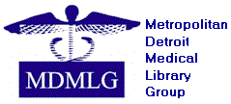 Student Representative
Annual Report 2019-2020

Goals & Objectives

- To bring awareness of the MDMLG to SIS students from surrounding universities.
- To highlight professional development opportunities at reduced rates, employment opportunities, mentoring, awards, and more.
- To emphasize the support available by connecting with information experts who can assist in personal and professional goals.
- To show the value of joining discussions with the MDMLG community.

Accomplishments

Over the past year, I have reached out to students from Wayne State University and the University of Michigan as well as through SIS student groups to spark interest and generating new members. Our world turned upside down when the pandemic hit and we are all adjusting to this new normal. I can’t think of a better time to connect with a supportive online community.

Respectfully submitted,

Michelle Rau
Student Representative

